Infosys Springboard Virtual Internship 6.0 Completion Report

# Team Details <Do not mention any personally identifiable information like email ID, institute details, mobile phone number etc.>

Batch Number: **NeuroFleetX AI Powered Urban Fleet and Traffic Intelligence**

**Start date :** 05-11-2025

**Names:**

1.Pamala Dinesh Kumar

2.Narmadha L

3.Ganesh S

4.Nitin Kamalesh

Internship Duration: 8 Weeks

# 1. Project Title

NeuroFleetX AI Powered Urban Fleet and Traffic Intelligence

**2. Project Objective**

The objective of NeuroFleetX is to build an intelligent fleet and traffic monitoring system that supports administrators, managers, and drivers in handling urban traffic more efficiently. The system collects and interprets vehicle movement and traffic-related information to identify congestion levels, risky locations, and unsafe road conditions. By using interactive dashboards, maps, and visual analytics, NeuroFleetX converts complex traffic data into simple and understandable insights.

The platform includes features such as live vehicle monitoring, alert notifications, traffic risk evaluation, and route guidance to improve safety and operational performance. A role-based access model is followed so that Admins, Managers, and Drivers can access only the information and controls relevant to their responsibilities. Although the current version uses basic AI-assisted and rule-based logic, the system is designed to support future integration of advanced machine learning models for automated traffic prediction and smarter decision-making. Overall, NeuroFleetX aims to improve traffic visibility, reduce manual effort, and support the development of smart urban transportation solutions.

**3. Project description in detail**

NeuroFleetX is an intelligent fleet and traffic management platform developed to overcome the growing challenges of monitoring vehicles and controlling traffic in urban areas. As cities continue to expand and vehicle numbers increase rapidly, traditional traffic management approaches are no longer sufficient to ensure smooth traffic flow and road safety. NeuroFleetX addresses this issue by providing a centralized digital solution to observe traffic conditions, vehicle activity, and risk-prone zones in a structured and visual format.

The system is developed as a **full-stack web application**, where the frontend focuses on interactive dashboards, charts, and map-based views, while the backend handles data processing, storage, security, and business logic. User interaction with the system is based on predefined roles—Admin, Manager, and Driver—each having restricted and well-defined access to system features.

The **Admin module** offers complete authority over the platform. Admin users can manage system users, drivers, and vehicles, monitor overall traffic conditions, analyze congestion and risk zones, handle alerts, and view analytics through dashboards and charts. The admin dashboard provides a city-wide snapshot by displaying vehicle status, congestion intensity, and high-risk areas in one consolidated view.

The **Manager module** is focused on operational monitoring. Managers are responsible for updating traffic information for various locations, tracking congestion levels, identifying risk zones, monitoring fleet movement, and responding to alerts generated by the system. This role ensures smooth daily management of traffic and fleet operations.

The **Driver module** is designed for users who are actively on the road. Drivers can create and manage trips, follow recommended routes, share their location using GPS-based check-ins, monitor assigned vehicle status, and receive traffic or safety-related alerts. These features help drivers avoid congested areas and travel more safely.

NeuroFleetX also includes **AI-assisted functionalities** such as traffic data analysis, congestion classification, risk zone detection, route recommendations, and alert generation. In the current phase, these features are implemented using basic AI logic and rule-based methods. The frontend visually represents this information using charts, color-coded indicators, and map overlays, making complex traffic data easier to understand.

While the present implementation relies on sample or manually entered data, the system architecture is designed to support future enhancements. Advanced AI and machine learning models can later be integrated to enable real-time data collection, automatic traffic prediction, accident detection, and intelligent route optimization.

Overall, NeuroFleetX provides a scalable and flexible foundation for building an intelligent traffic and fleet management system. It enhances traffic awareness, improves road safety, reduces manual supervision, and supports informed decision-making in modern urban transportation environments.

**4. Timeline Overview**

|  |  |  |
| --- | --- | --- |
| Week | Activities Planned | Activities Completed |
| Week 1 | Requirement gathering, problem analysis, and project planning | Requirements finalized, project idea approved, team roles assigned |
| Week 2 | Project scope definition and technology selection | Scope documented, tech stack finalized (React, Spring Boot, MySQL, JWT) |
| Week 3 | Database design and backend setup | Database schema created and tested with sample datasets |
| Week 4 | Authentication and role-based access implementation | Login & registration pages completed, JWT authentication implemented |
| Week 5 | |  | | --- | |  |  |  | | --- | | Admin module development | | Admin dashboard, user management, driver management, and vehicle management completed. |
| Week 6 | Manager and Driver module UI development | Manager dashboard, traffic management UI, driver dashboard, trip management UI completed |
| Week 7 | Alerts module and frontend integration | Alerts page implemented, create/resolve alerts, real-time refresh added |
| Week 8 | |  | | --- | |  | | AI Analytics frontend and system integration | | | AI Analytics UI completed, charts and risk visualization added, documentation finalized |

# 5a. Key Milestones

|  |  |  |
| --- | --- | --- |
| Milestone | Description | Date Achieved |
| Project Kickoff | Project kickoff defined objectives, scope, and roles. | 10 – Nov - 2025 |
| Prototype/First Draft | Developed the prototype for NeuroFleetX AI Powered Urban Fleet and Traffic Intelligence | 24- Nov - 2025 |
| Mid-Term Review | Completed mid-term review to assess progress and refine project approach. | 02- Dec - 2025 |
| Final Submission | Submitted the completed Budgetwise project with full functionality and documentation. | 17- Dec - 2025 |
| Presentation | Prepared and delivered the project presentation showcasing features and outcomes. | 3- jan - 2025 |

# 5b. Project execution details

* **Requirement Analysis**  
  Collected and analyzed project requirements, studied existing traffic management challenges, defined the system scope, and finalized clear project objectives.
* **Technology Selection**  
  Selected React for frontend development, Spring Boot for backend services, MySQL for database management, and JWT for secure authentication. OpenStreetMap was chosen for map-based visualization.
* **System Design**  
  Designed database entities, API workflow, role-based access control structure, and basic user interface layouts for Admin, Manager, and Driver dashboards.
* **Authentication & Role Setup**  
  Implemented secure user registration and login functionality using JWT-based authentication with role-based access control.
* **Core Module Development**  
  Developed core modules including Admin Dashboard, Vehicle Management, User Management, and Driver Management.
* **Traffic & Fleet Features**  
  Implemented traffic data handling, fleet status monitoring, and basic trip-related functionalities.
* **Alerts Module Implementation**  
  Developed alert creation, viewing, severity classification, and resolution features with real-time data refresh support.
* **AI Analytics (Frontend)**  
  Designed the AI Analytics dashboard using charts and color indicators to visualize traffic congestion levels and risk zones.
* **AI Tools Integration (Basic Level)**  
  Implemented basic AI-assisted features such as route exploration and traffic analysis support.
* **Testing & Integration**  
  Performed frontend and backend integration testing, verified API responses, and resolved UI and logic-related issues.
* **Documentation & Presentation**  
  Prepared comprehensive project documentation, presentation slides (PPT), code explanations, and delivered the final project presentation.

# 6. Snapshots / Screenshots

**Step 1 : Go to Github and clone the Repository in your system then open in VS Code to do the execution , here is the github repo link :** https://github.com/NarmadhaLoganathan/NeuroFleetX-TeamB

**Step 2 : Folders,Terminal**

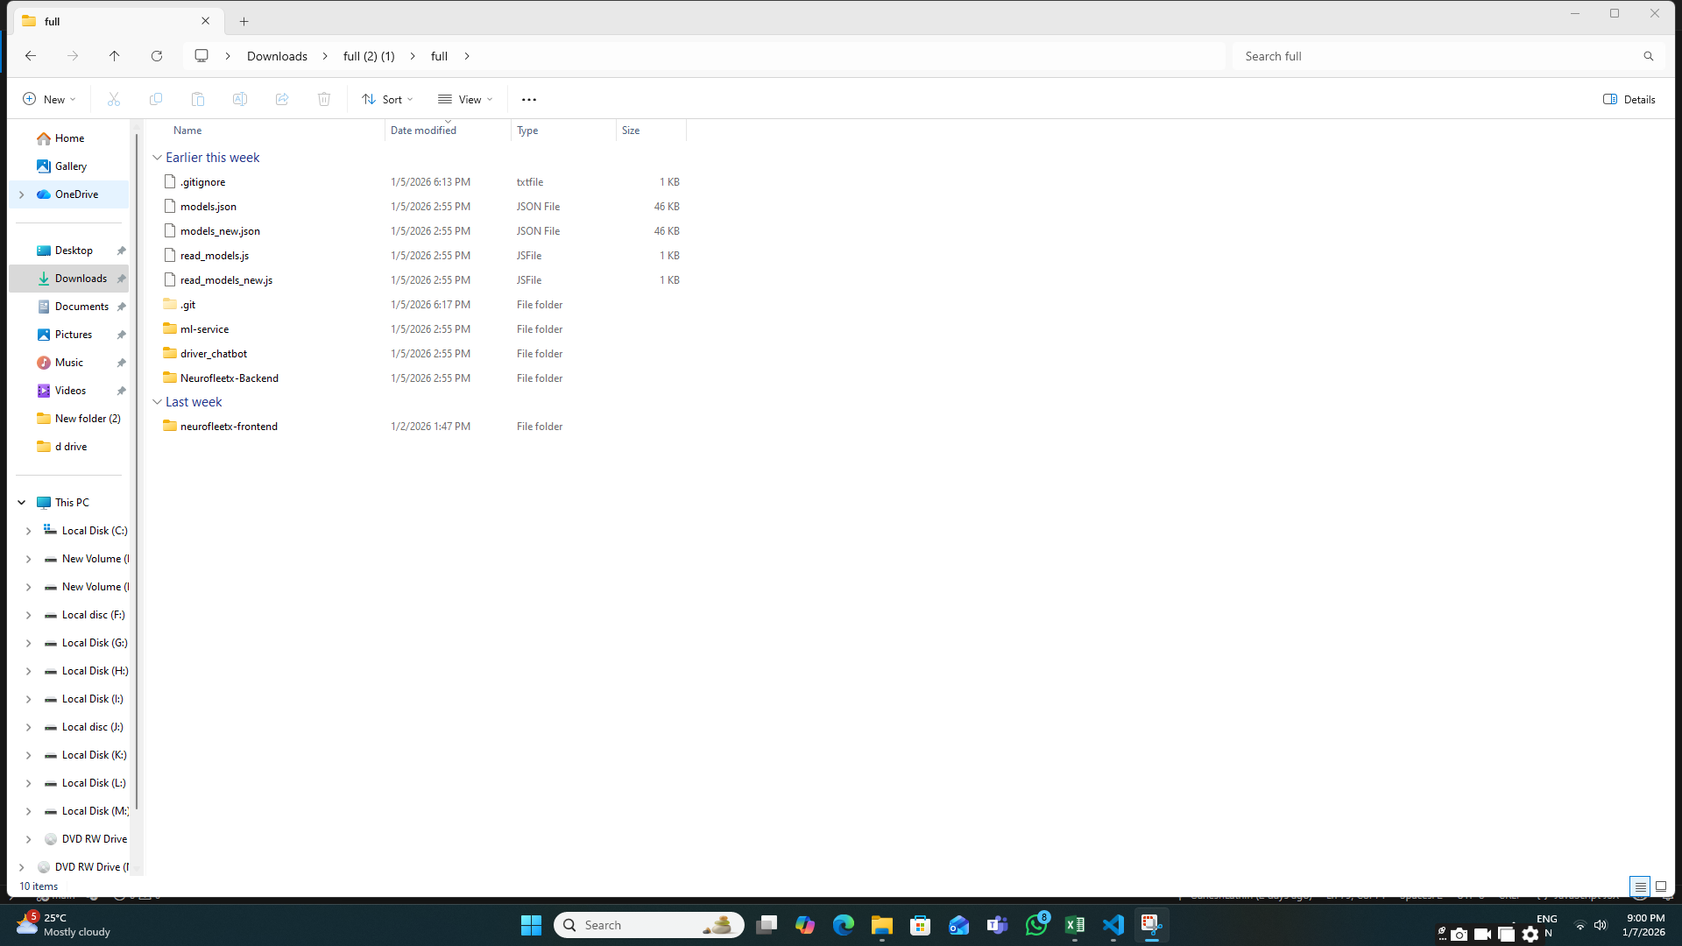

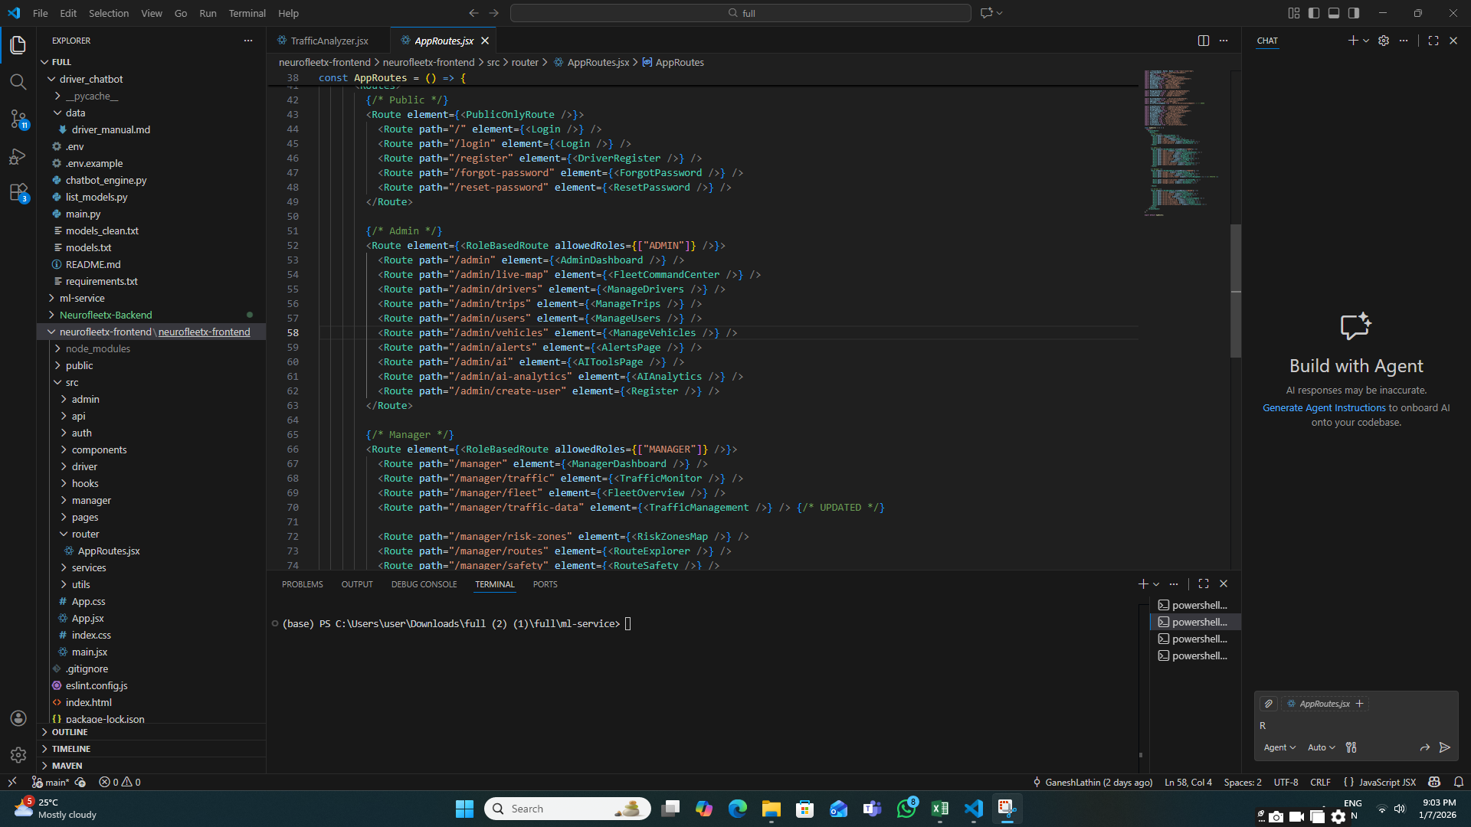

**Step 3 : Login / Signup Navigation**

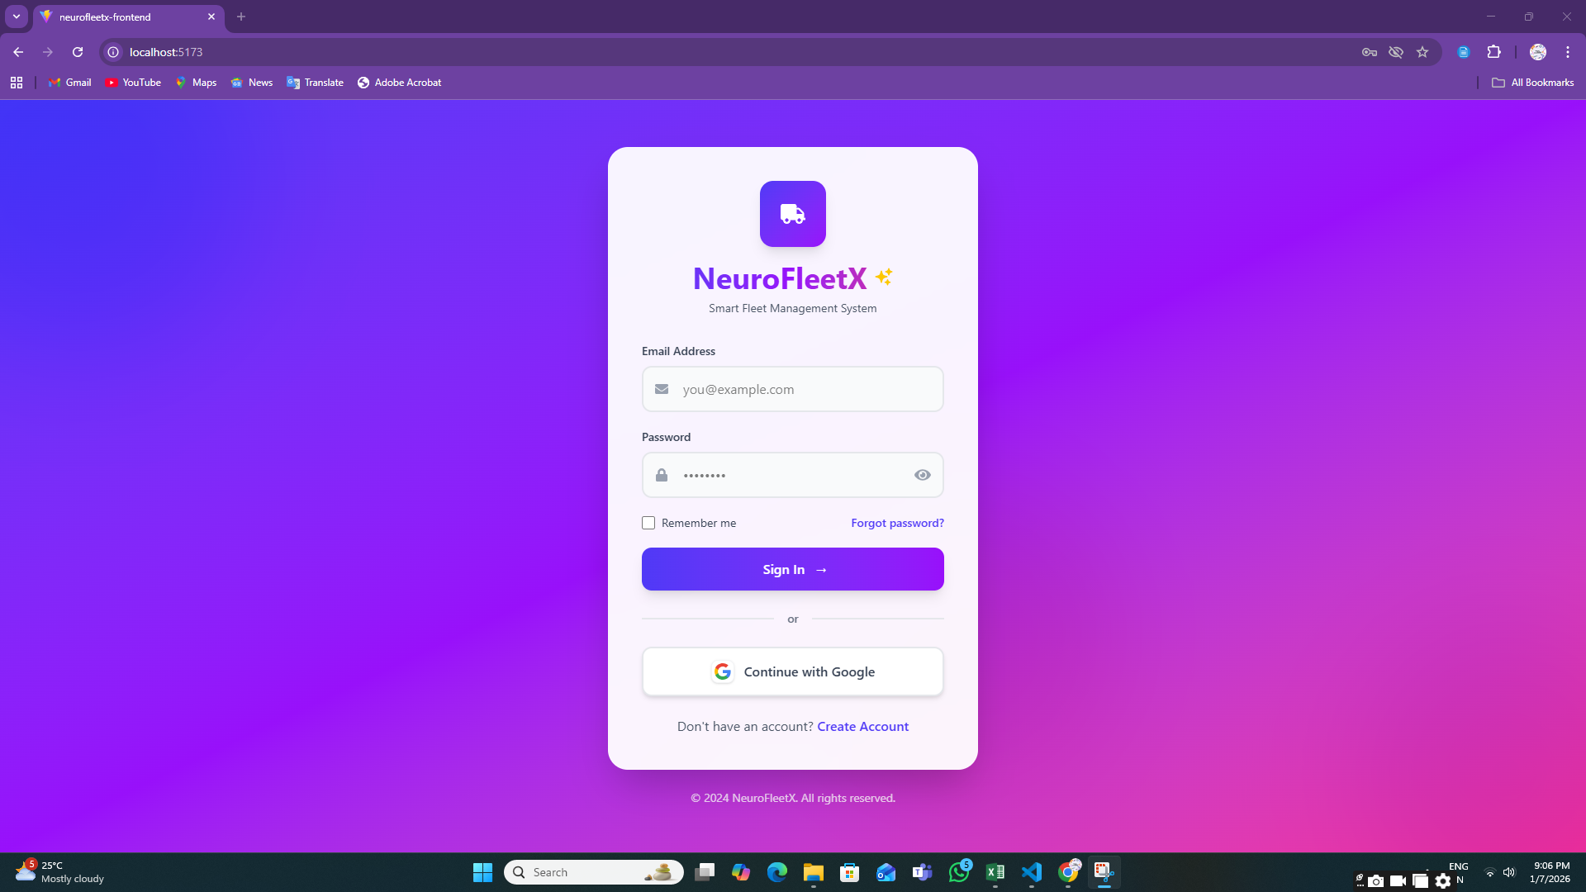 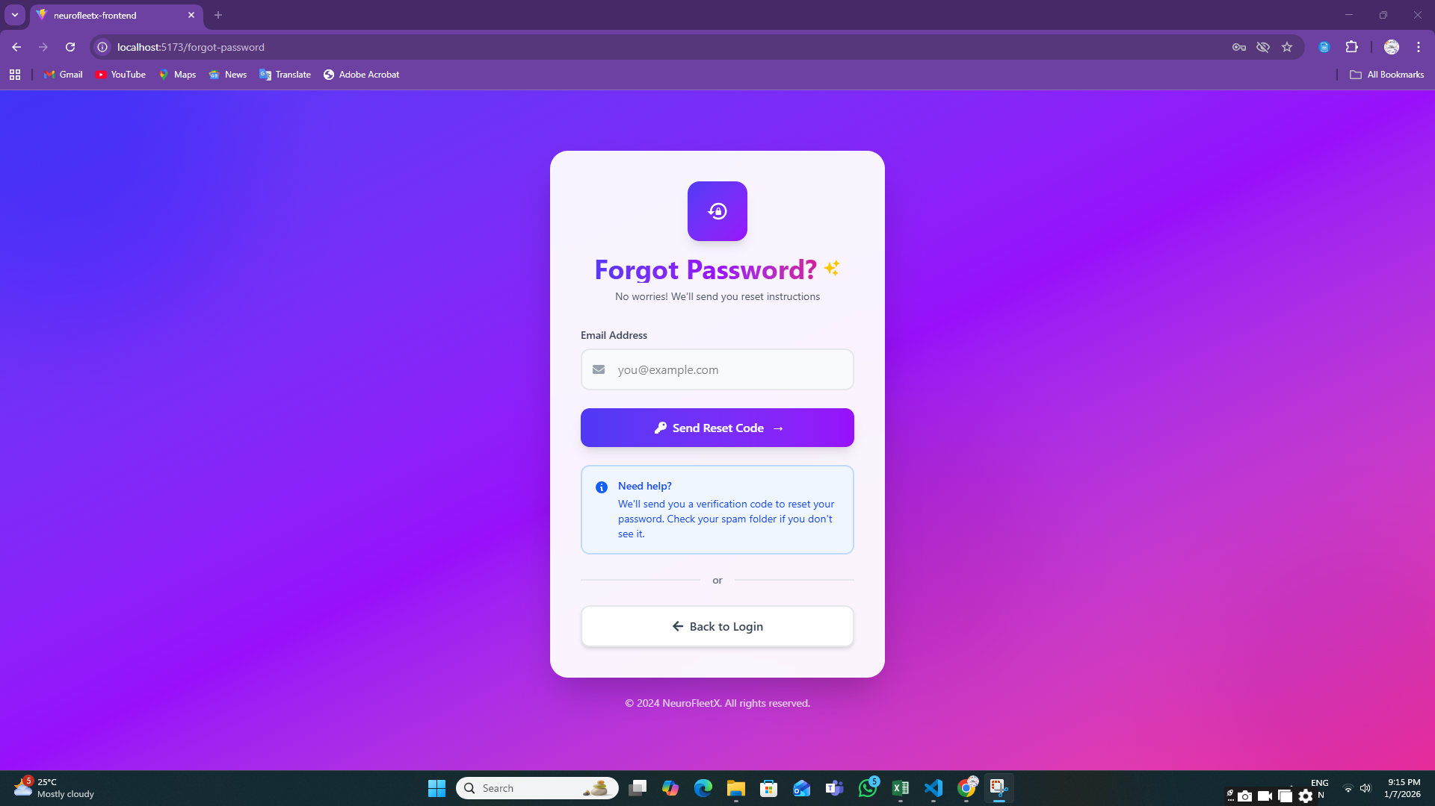

**Step 4: Registration Page**

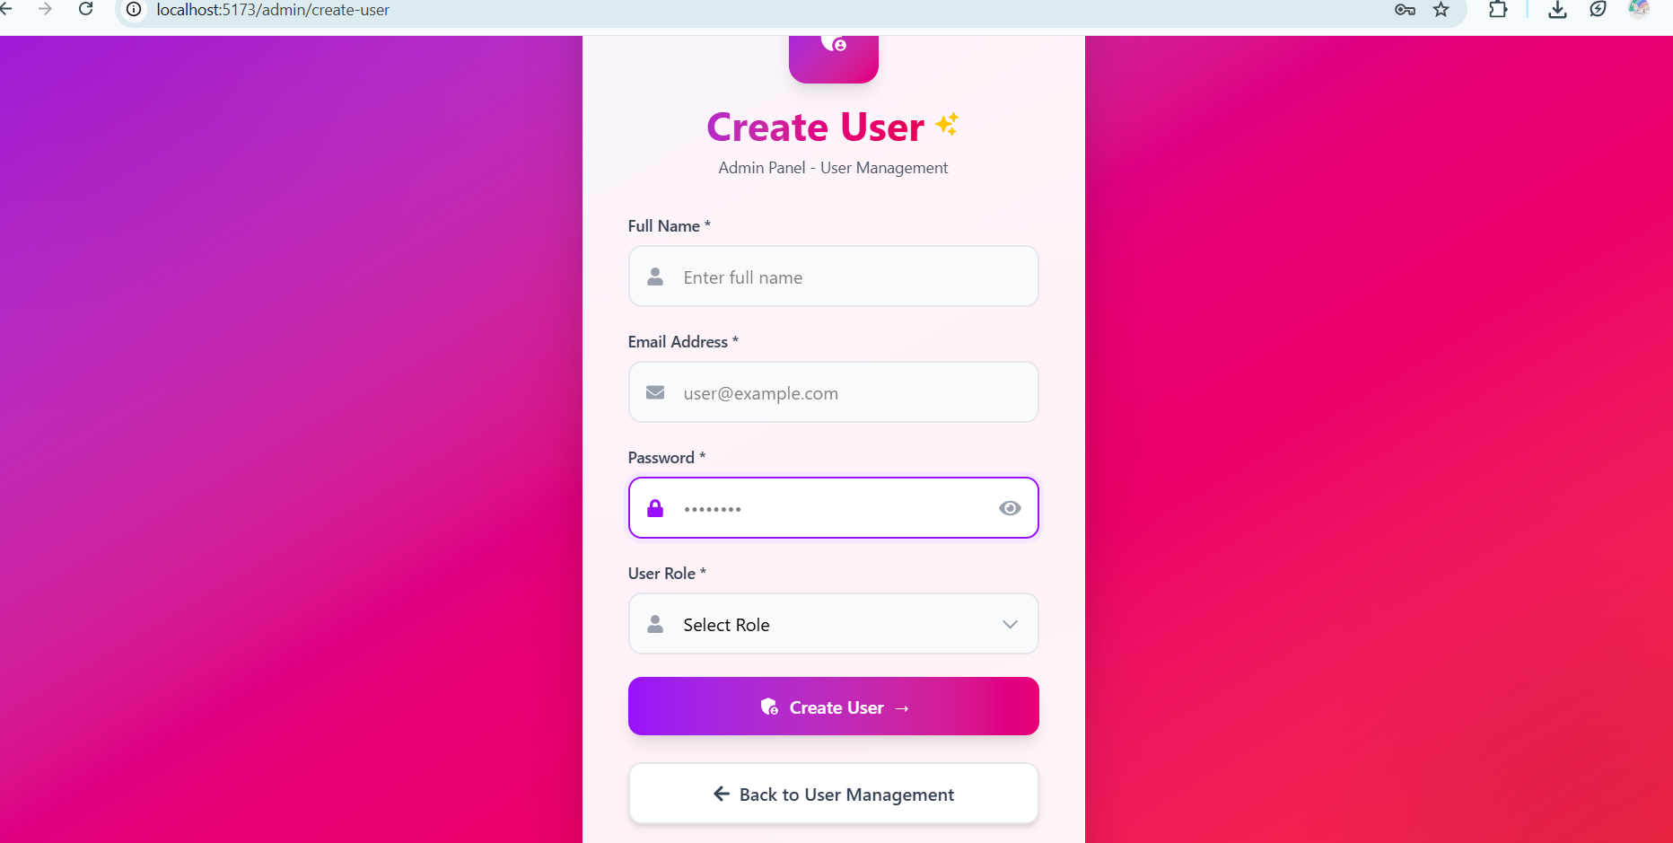

**Step 5: Role-Based Redirection**

After successful login, users are automatically redirected to their respective dashboards:

* **Admin Dashboard**

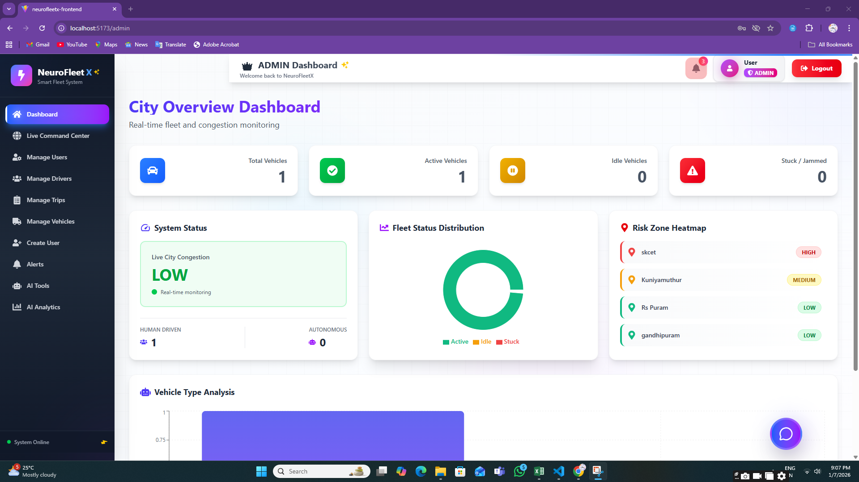

* **Manager Dashboard**

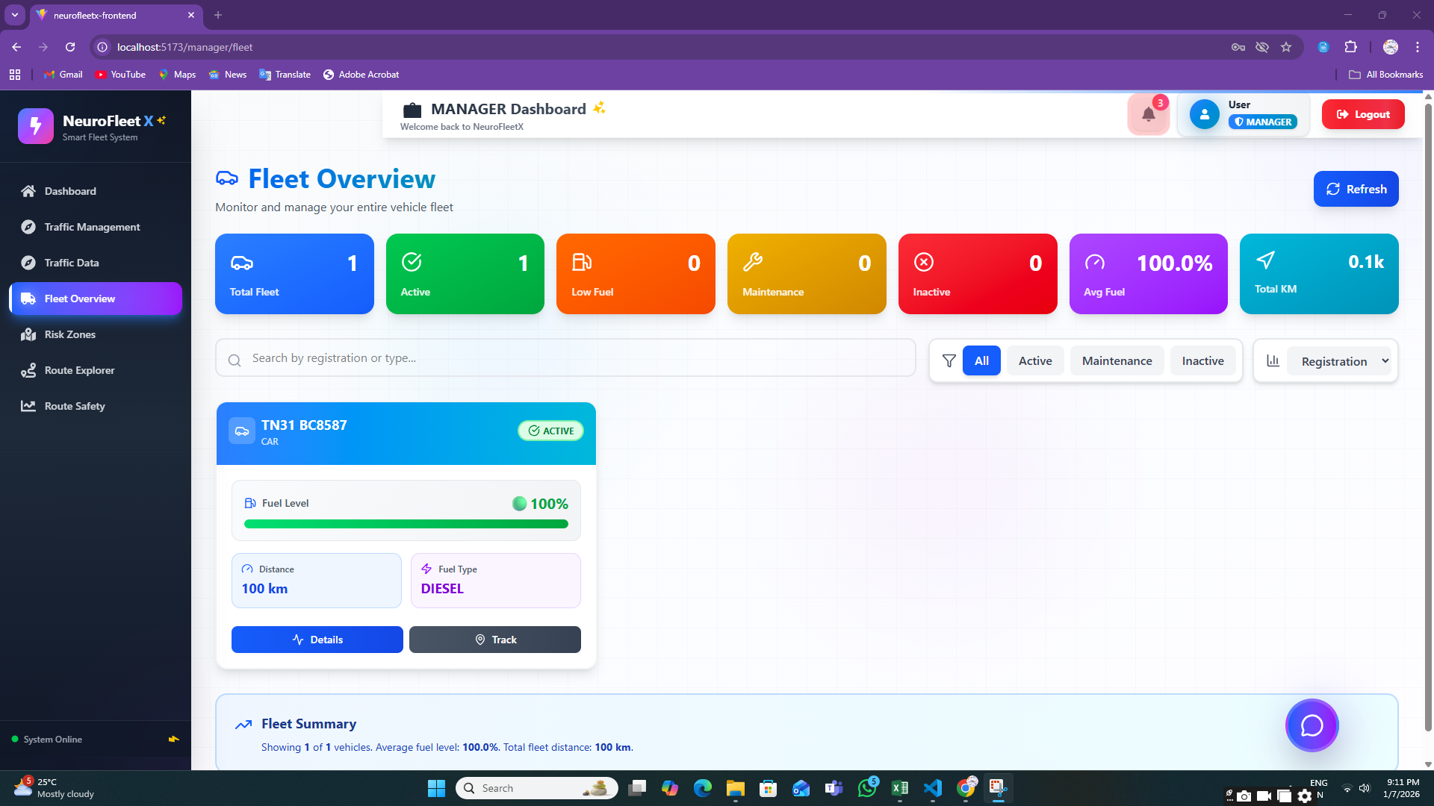

* **Driver Dashboard**

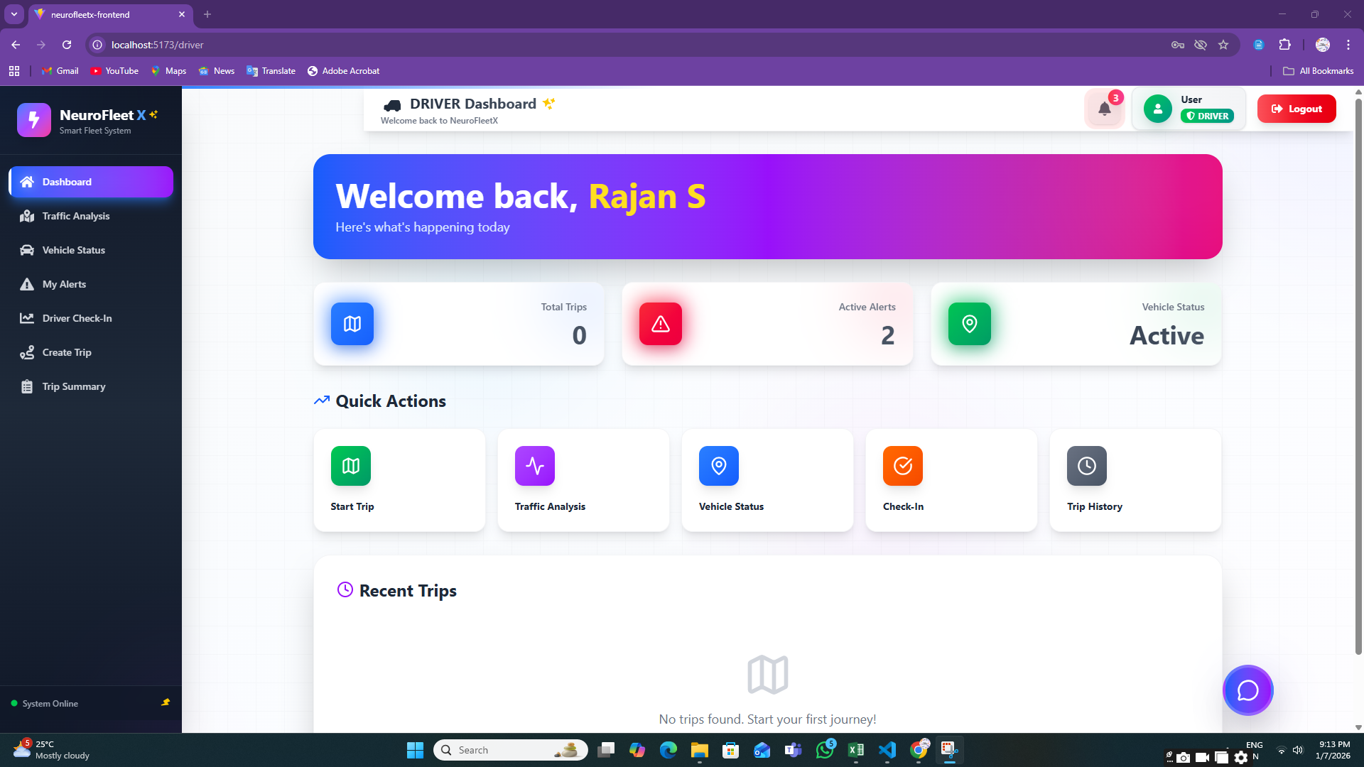

This confirms role-based access control.

**Step 6: ADMIN MODULE**

**6.1:** **Vehicle Management Page**

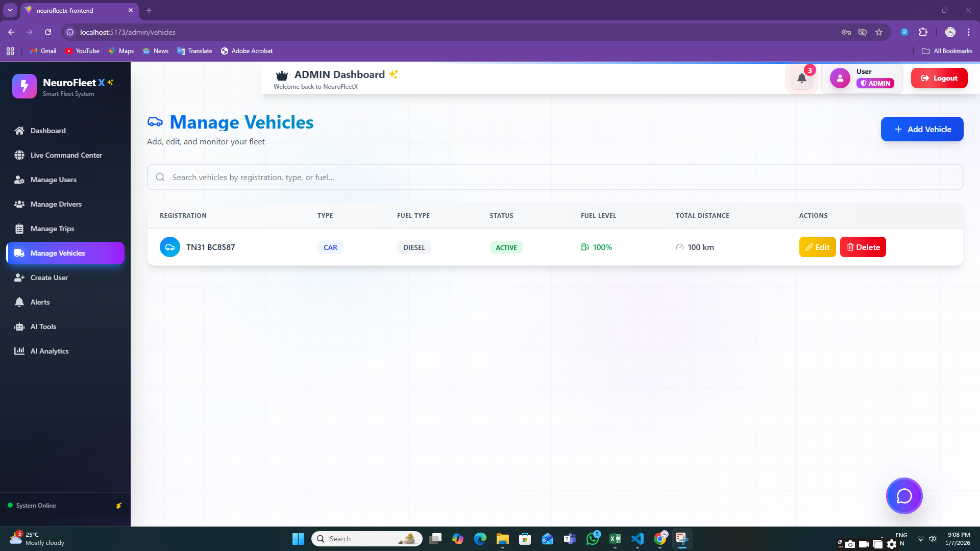

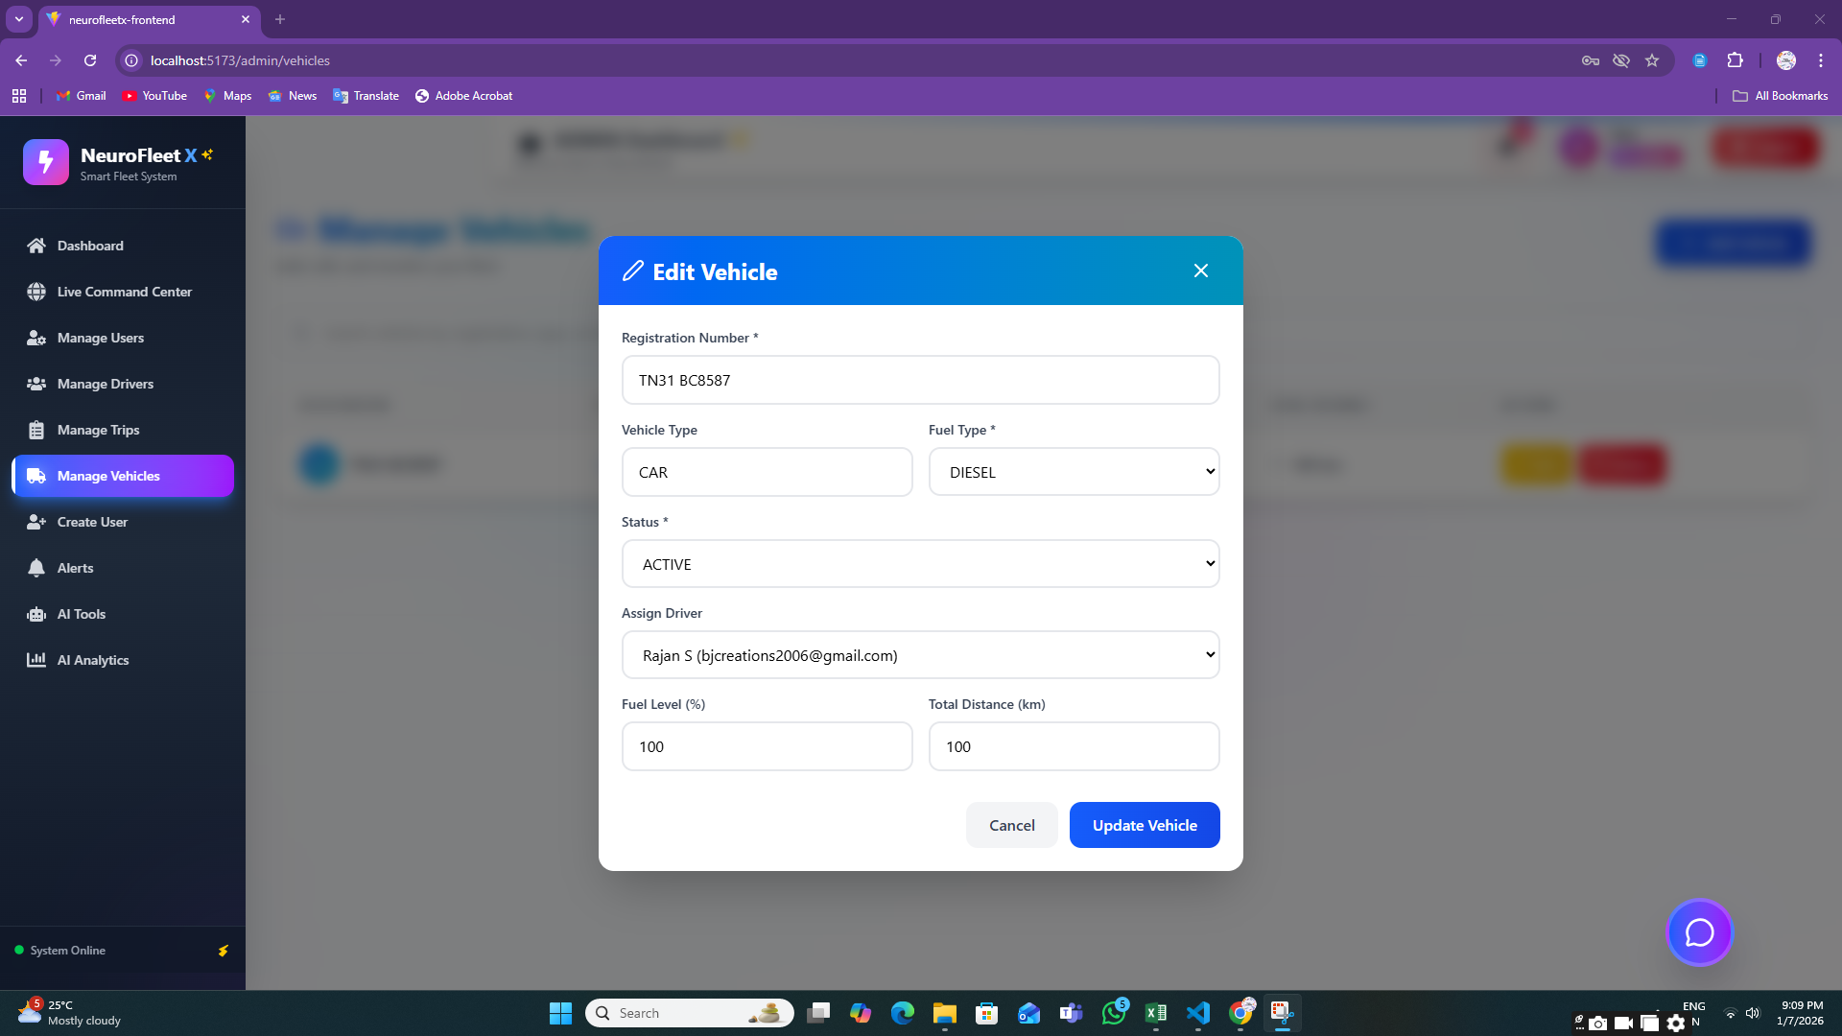

**6.2:** **User Management Page**

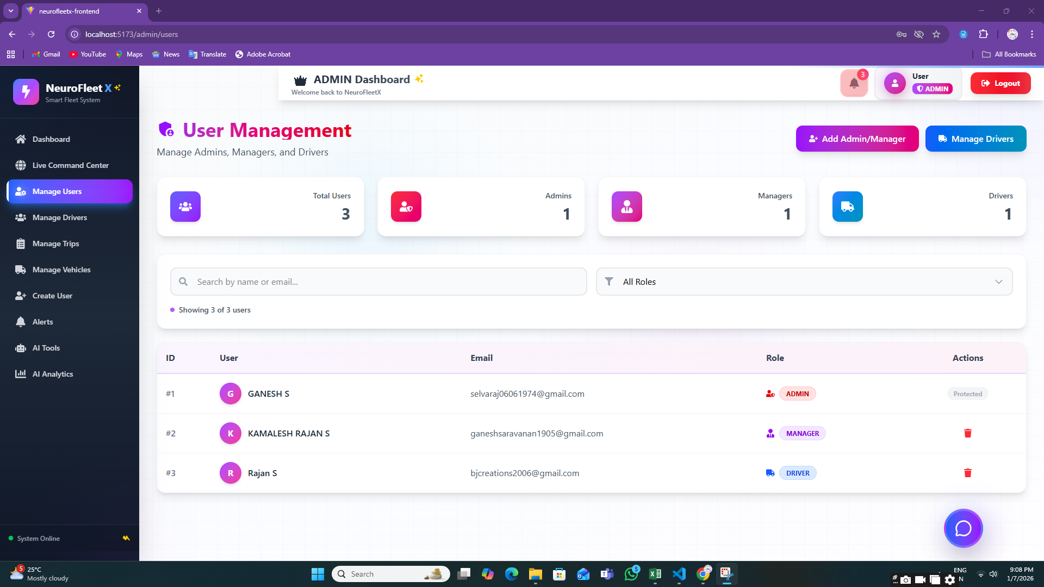

**6.3:** **Driver Management Page**

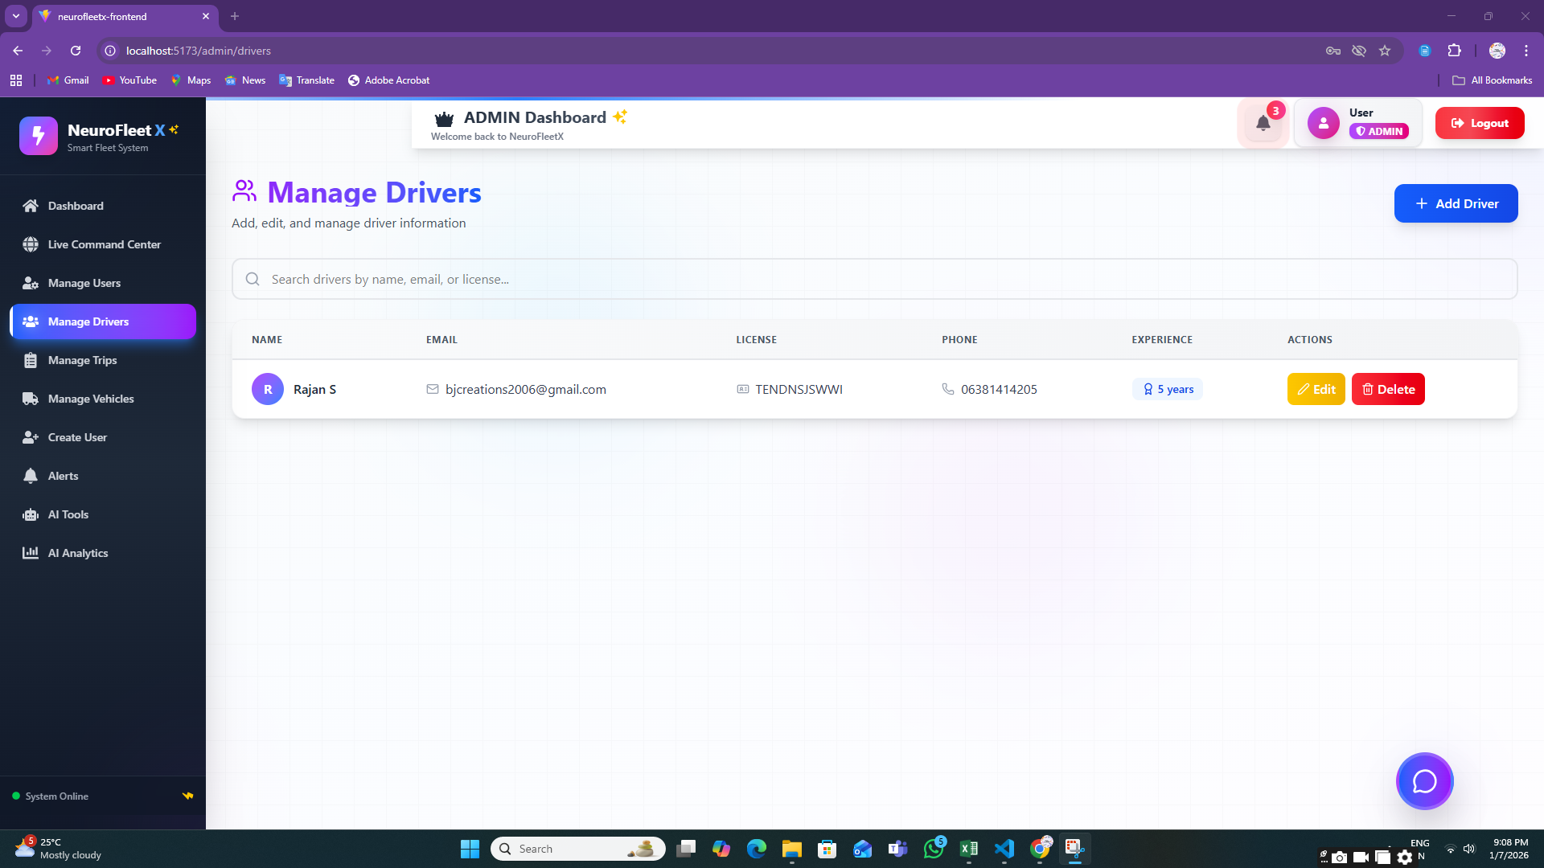

**6.4:** **Alerts Page (Admin View)**

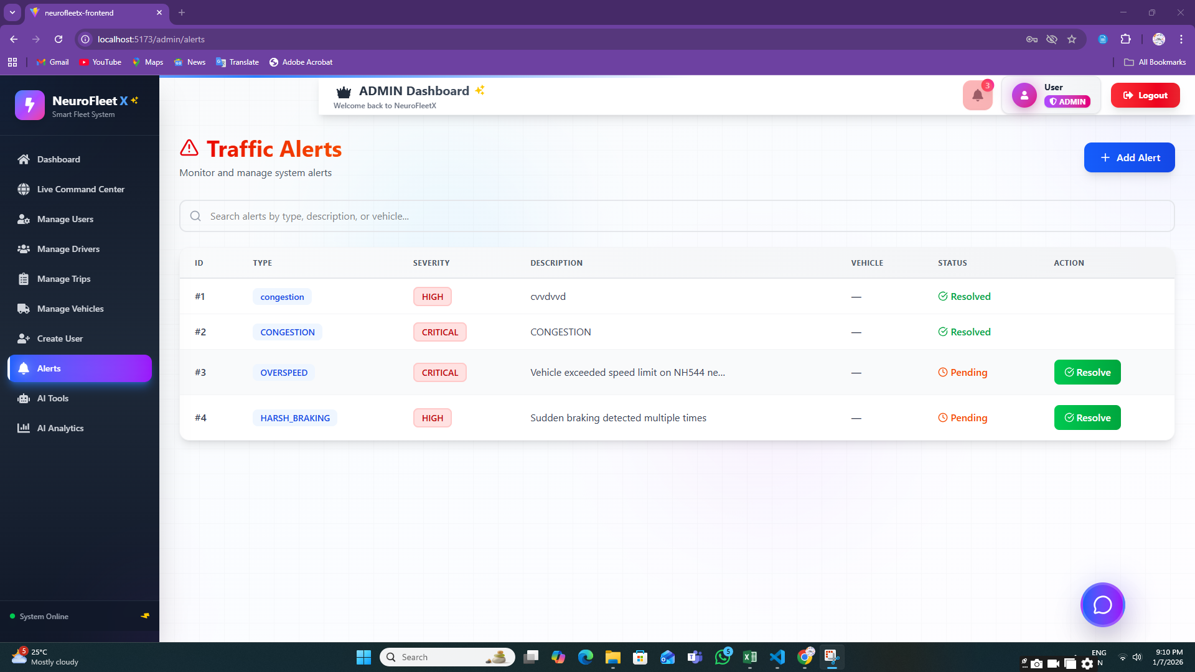

**6.5:** **AI Analytics Page**

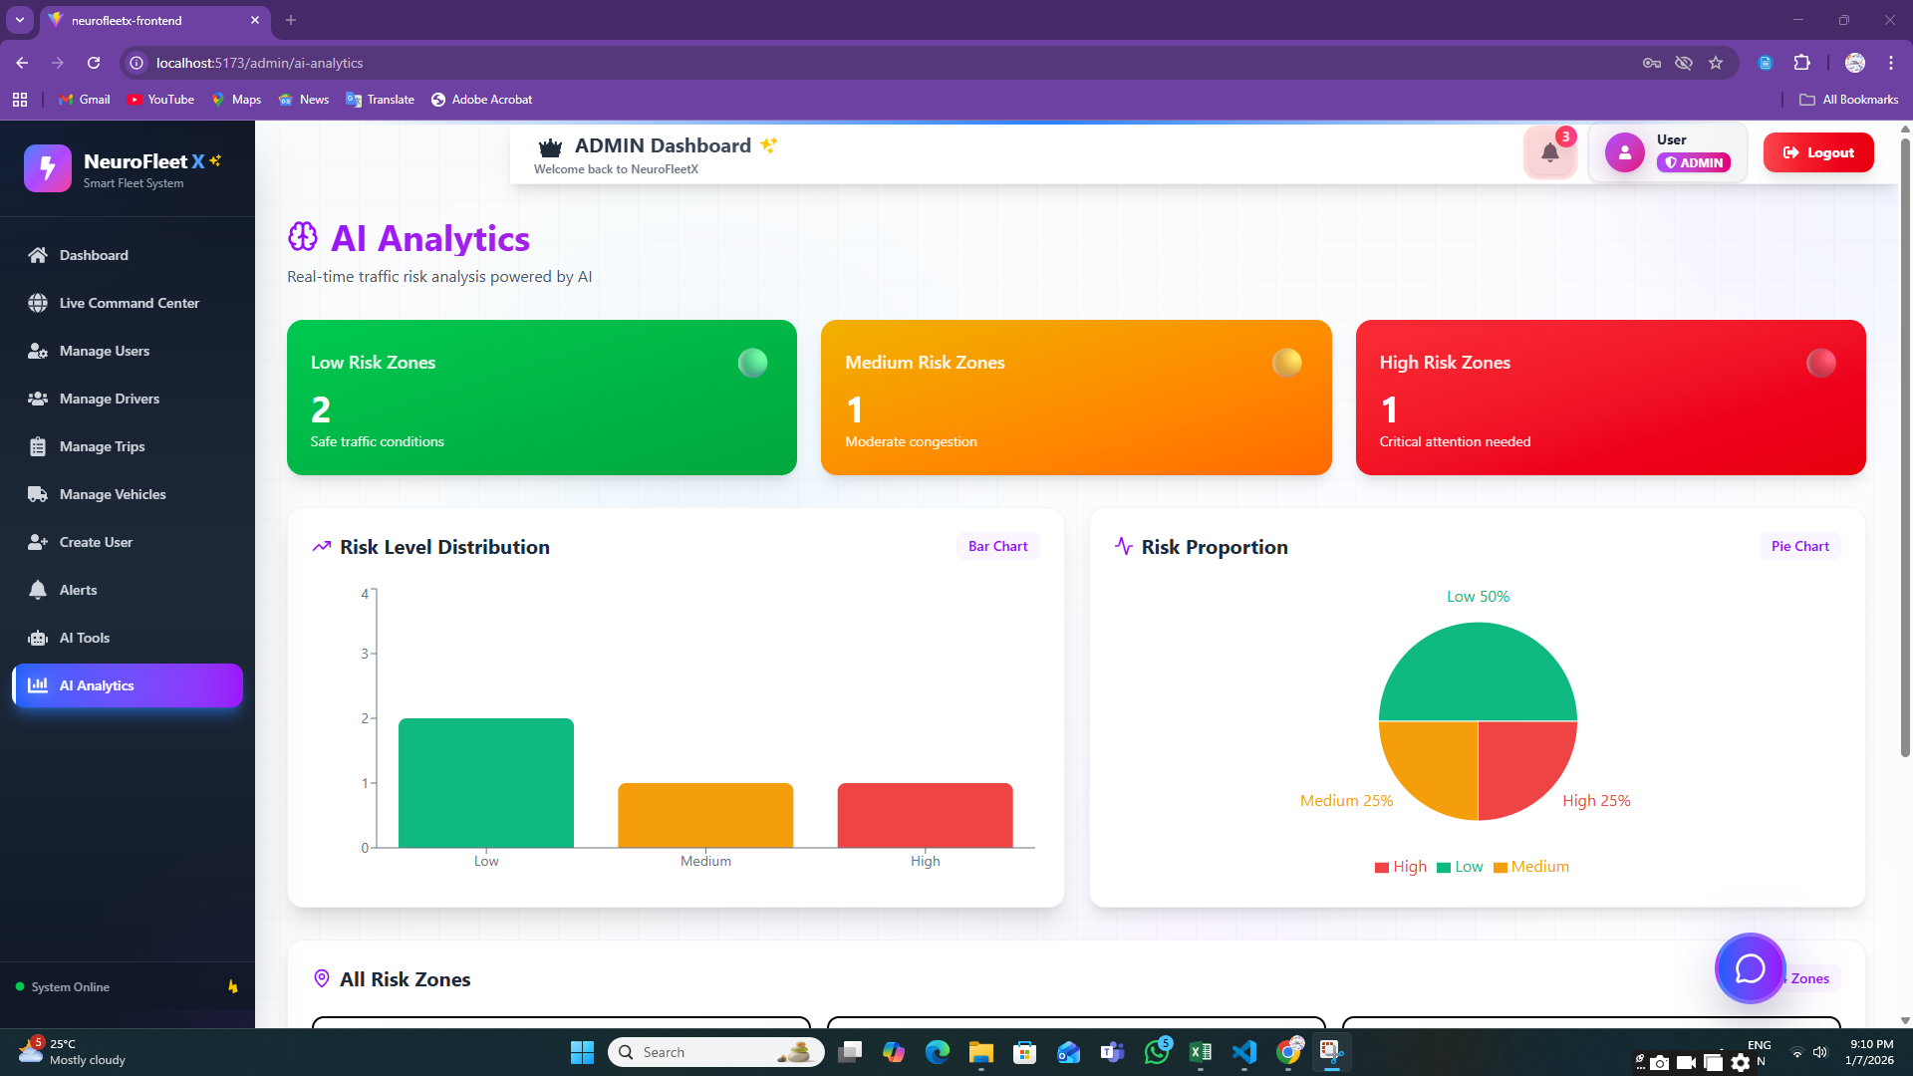

**6.6:AI Tools**

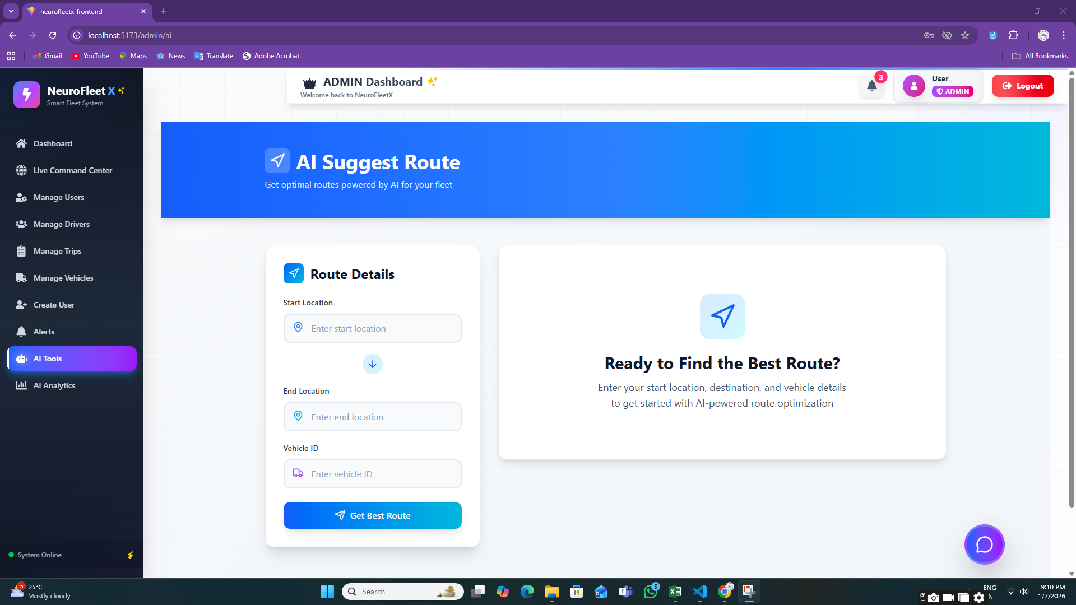

**6.7:Manage Trips**

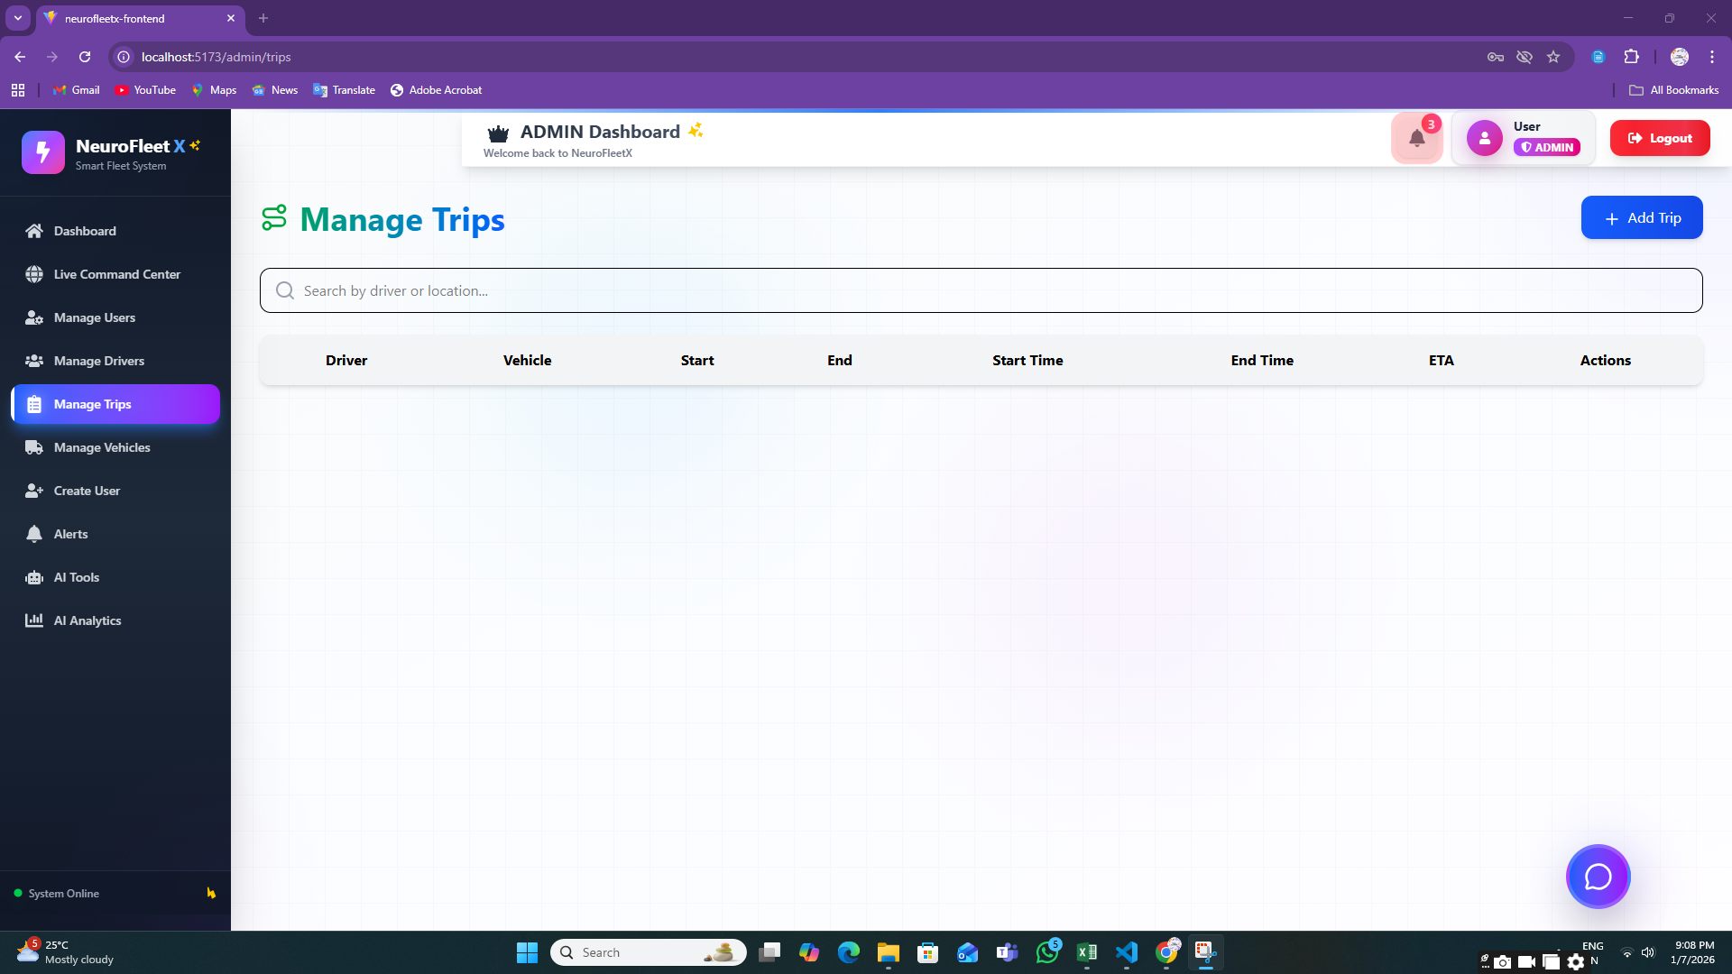

**Step 7:** **MANAGER MODULE**

**7.1:Traffic Management Page**

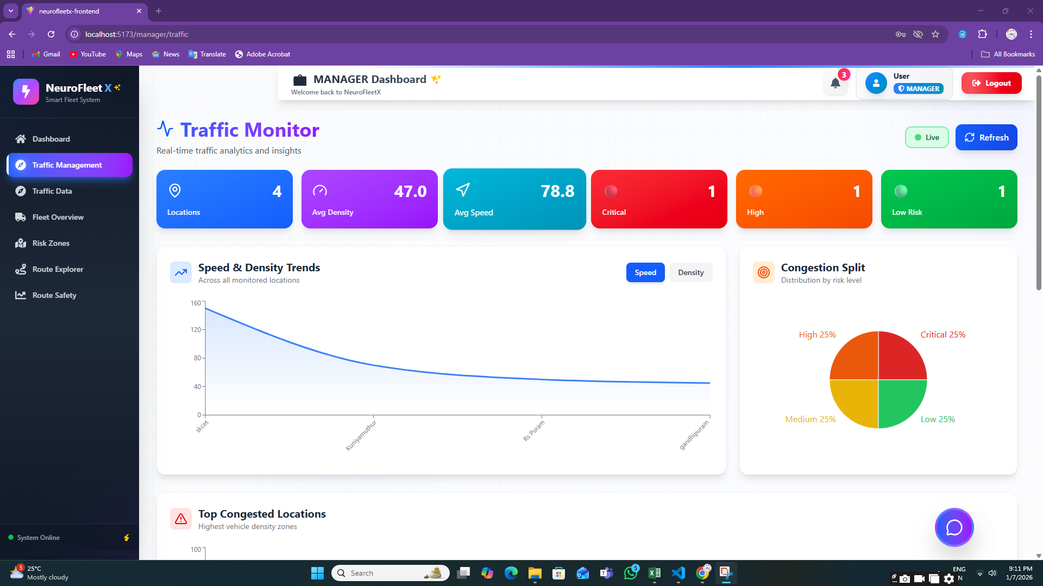

**7.2:** **Risk Zone Map**

**7.3:Traffic Data**

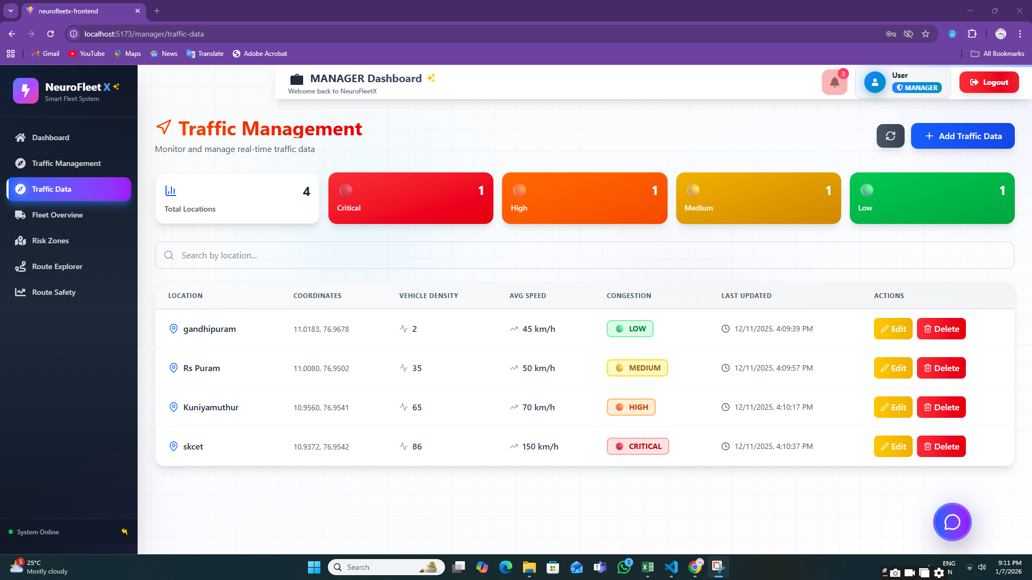

**7.4:Route Explorer**

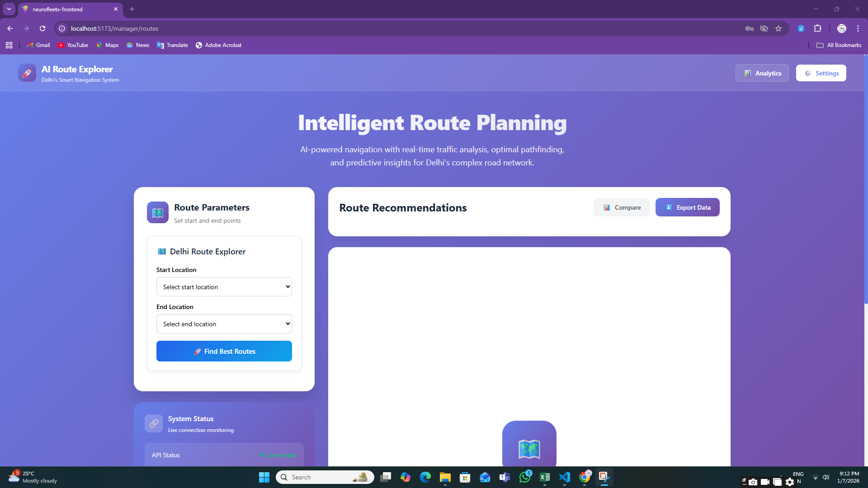

**7.5:Route Safety Analysis**

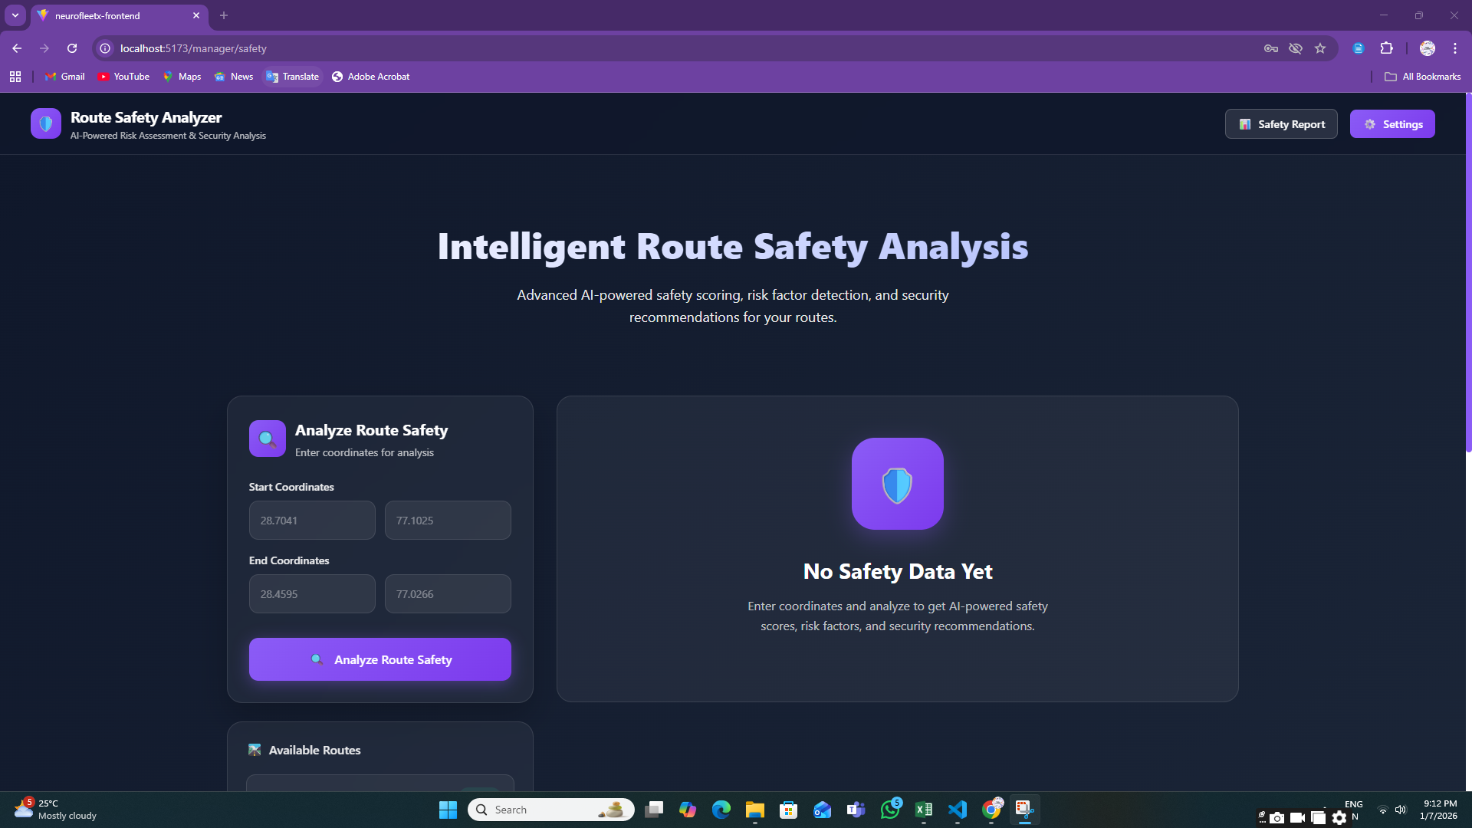

**Step 8:** **DRIVER MODULE**

**8.1:** **Create Trip Page**

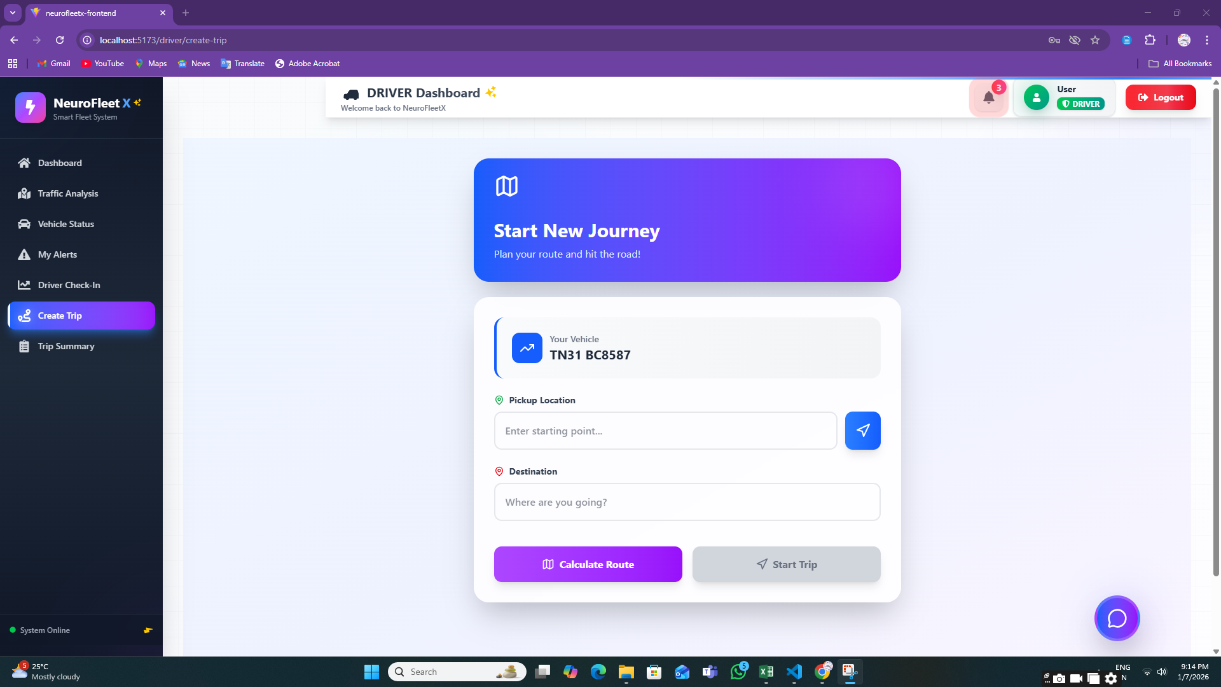

**8.2:** **Route Explorer**

**8.3:** **Traffic Analysis Page**

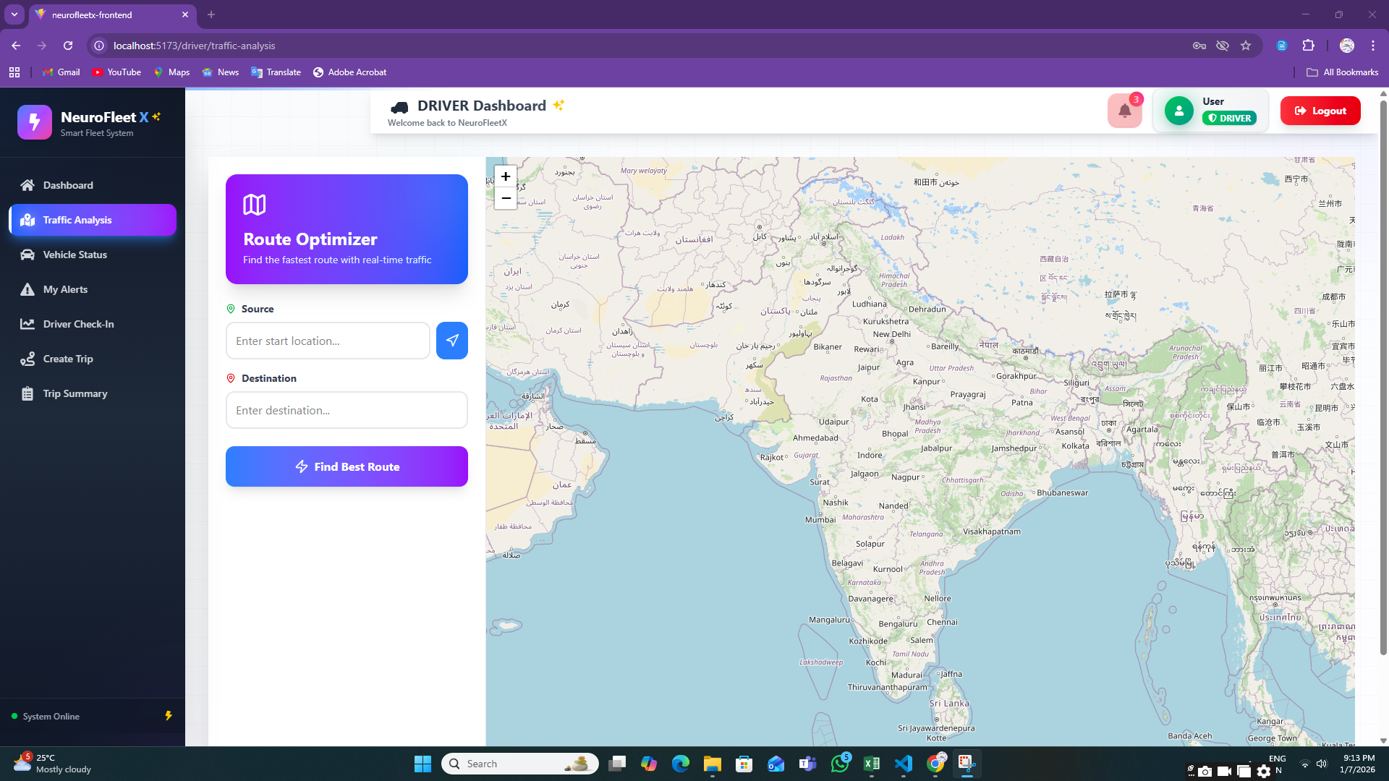

**8.4:** **Vehicle Status Page**

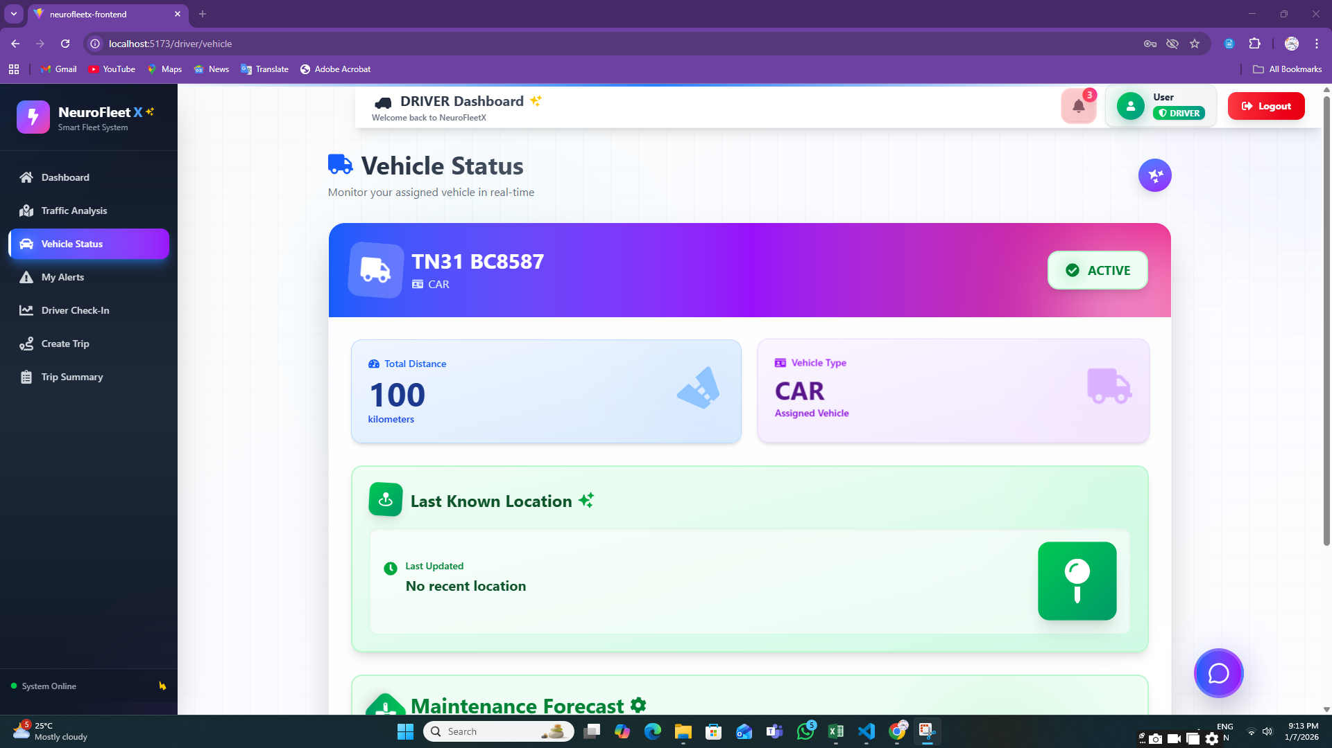

**8.5:** **My Alerts Page**

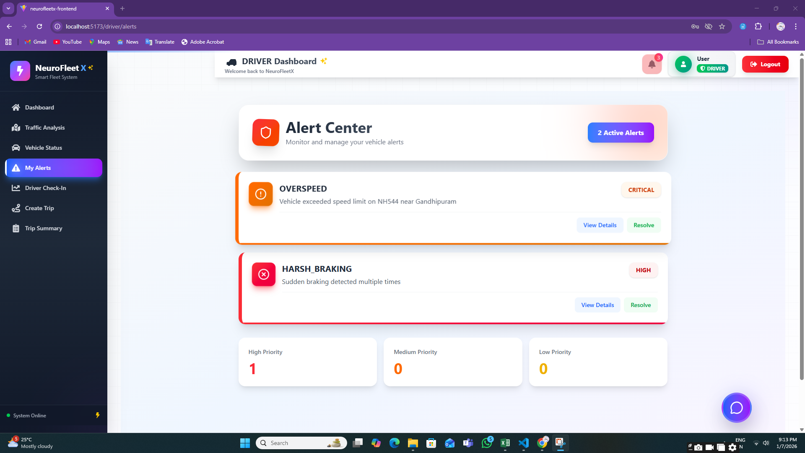

**8.6:** **Driver Check-In**

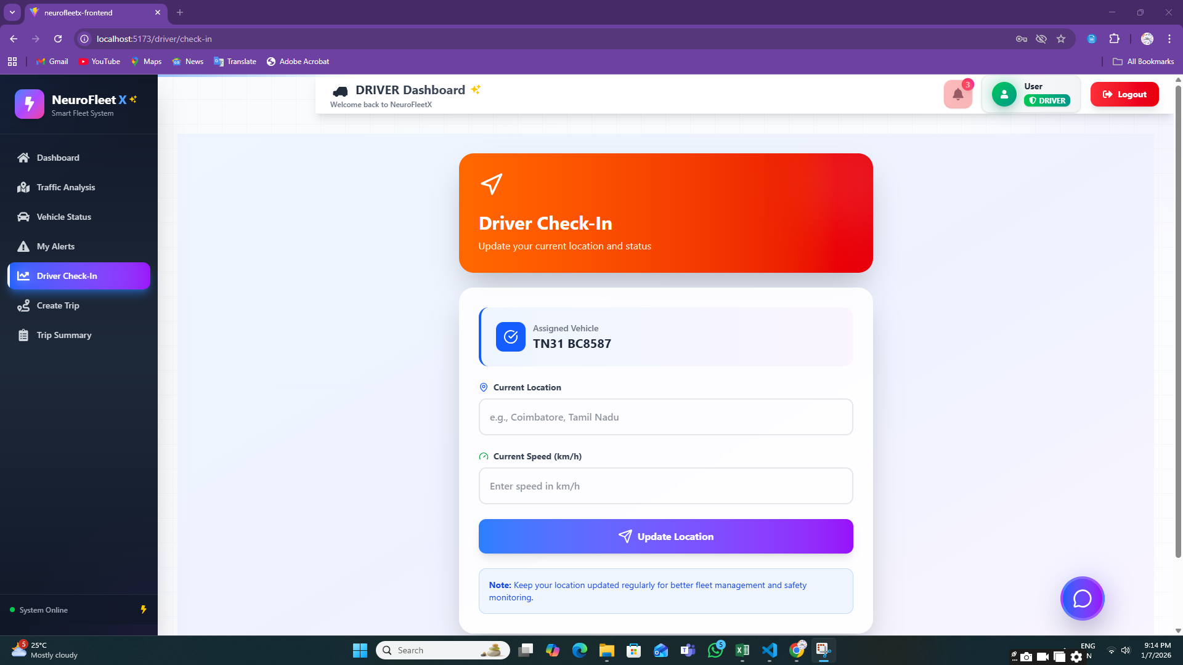

**8.7:** **Trip Summary Page**

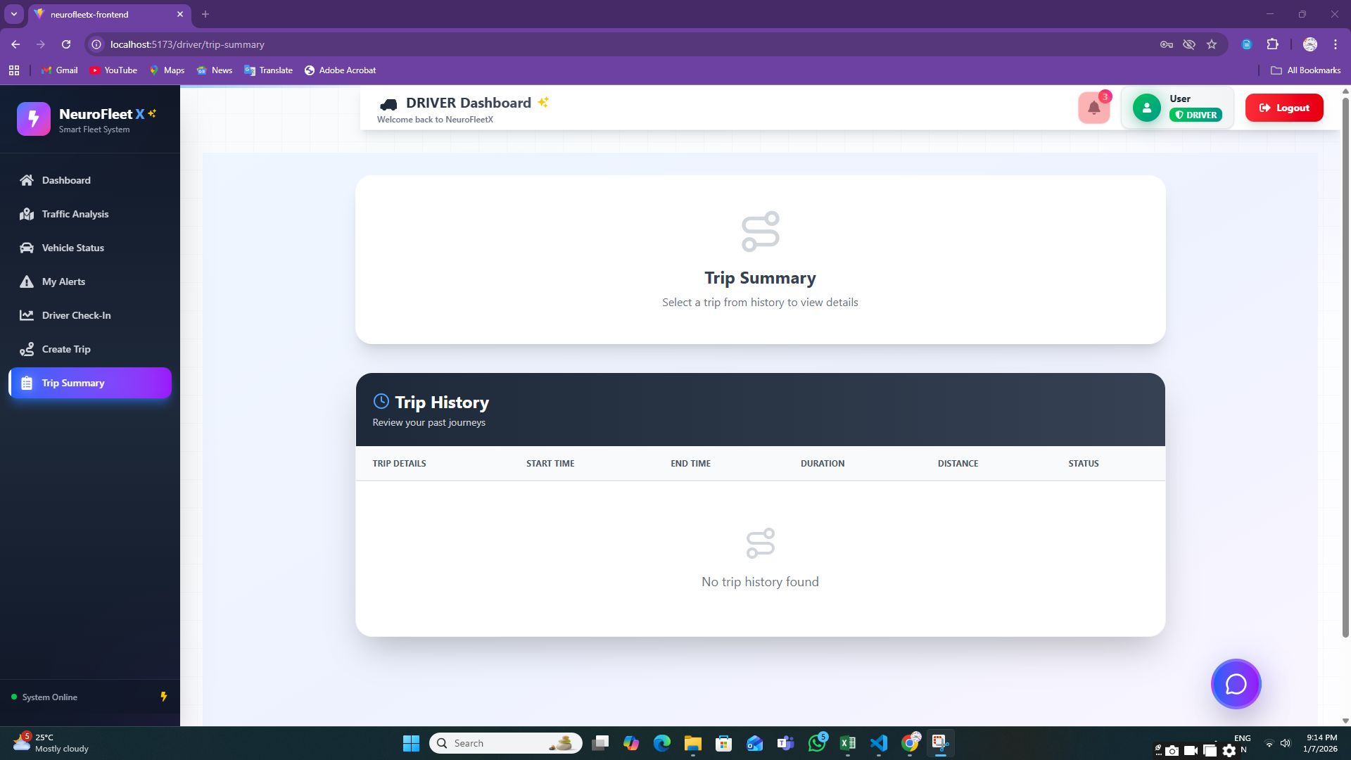

**7. Challenges Faced**

* **Limited Real-Time Traffic Data**Accessing real, live traffic data was difficult, so dummy and manually entered data were used for development and testing.
* **AI & ML Understanding**Understanding AI concepts and deciding how to apply them to traffic prediction and risk analysis was challenging at the beginner level.
* **System Performance Limitations**Laptop performance and memory constraints made AI experimentation and backend processing difficult.
* **AI Integration Complexity**  
  Connecting AI-assisted logic with backend services and frontend dashboards required multiple trials and debugging.
* **Map & Location Handling**Working with maps, coordinates, and location-based data needed careful handling to avoid errors.
* **Role-Based Access Control**  
  Managing different permissions for Admin, Manager, and Driver using JWT required extra attention to security logic.
* **Time Management**  
  Balancing learning, development, debugging, documentation, and presentations within the given timeline was challenging.

# 8. Learnings & Skills Acquired

* **AI Concepts (Basic Level)**  
  Learned how AI can be used for traffic analysis, congestion detection, and route suggestions.
* **Full-Stack Development**  
  Gained hands-on experience in React (frontend), Spring Boot (backend), and MySQL (database).
* **JWT Authentication**  
  Learned how to secure applications using token-based authentication and role-based access.
* **Dashboard & Visualization Skills**  
  Developed dashboards using charts, color indicators, and maps to represent traffic and fleet data.
* **API Development & Integration**  
  Improved skills in building REST APIs and integrating frontend with backend services.
* **Problem Solving & Debugging**  
  Learned to identify errors, debug issues, and improve system stability.
* **Team Collaboration**  
  Improved communication and coordination by working together on shared modules and milestones.

**9. Testimonials from team**

Team Member 1:  
“This project helped me understand how AI concepts can be applied to real-world traffic problems and improved my backend development skills.”

Team Member 2:  
“I learned how to design dashboards and visualize traffic data in a simple and user-friendly way.”

Team Member 3:  
“Working on NeuroFleetX improved my understanding of authentication, role-based access, and system integration.”

Team Member 4:  
“This project gave me confidence to work on full-stack applications and understand how smart city solutions are built.”

**10. Conclusion**

# The NeuroFleetX project successfully showcases the implementation of a smart, role-based fleet and traffic management system. The system offers interactive dashboards, alert handling, traffic analysis, and basic AI-assisted functionalities that help improve traffic monitoring and road safety. Although advanced AI and machine learning models are not fully integrated in the current phase, the system is structured in a way that supports future enhancements and intelligent automation. Overall, this project provided valuable hands-on experience, strengthened technical skills, and offered practical exposure to intelligent transportation and fleet management solutions.

# 11. Acknowledgements

I would like to sincerely thank our **institution and organization** for providing the opportunity to work on the NeuroFleetX project and gain valuable practical exposure. I am deeply thankful to our **mentor** for their continuous support, guidance, and constructive feedback, which played an important role throughout the project journey.

I would also like to express my gratitude to my **team members** for their teamwork, cooperation, and dedication. Their constant support and collaboration greatly contributed to the successful completion of this project. Finally, I thank everyone who supported us directly or indirectly and helped make this learning experience meaningful and successful.